Chapter 3, Solution 41
5 Ω
i₃
i₁
i₂
i₃
+ –

6 V
–
+
8 V
1 Ω
4 Ω
2 Ω
10 Ω
i₂
i
0

For loop 1,
6 = 12i₁ – 2i₂ 3 = 6i₁ – i₂ (1)
For loop 2,
-8 = – 2i₁ +7i₂ – i₃ (2)
For loop 3,

-8 + 6 + 6i₃ – i₂ = 0 2 = – i₂ + 6i₃ (3)

We put (1), (2), and (3) in matrix form,

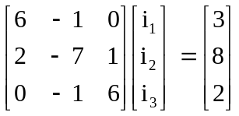

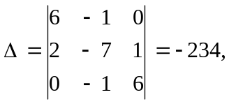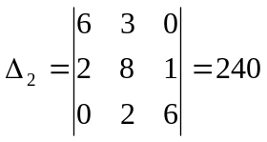

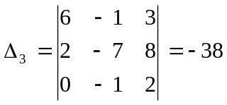

At node 0, i + i₂ = i₃ or i = i₃ – i₂ = 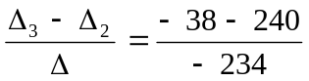= 1.188 A

